Web Development Report – Assignment 1.

In this report, we are referring to a website created that required three web pages namely, the landing page (Homepage), Tutorials page and References.

The website intended to be developed was a tutorials website for HTML, CSS and User Interface Design learning material. For this website, it was essential to use different programming languages in order to deliver. I have used HTML as the markup language for structure and CSS as the styling language for more aesthetic appeal.

In the initial development stages of the website, to get an idea of what the website should look like I had to sketch out wireframes. These wireframes were sketches on my notebook which I then later tried to replicate on to my website as close as I could. The design is based off the many resources found on the Nile site as good practice websites. The initial design that was planned can be seen below:

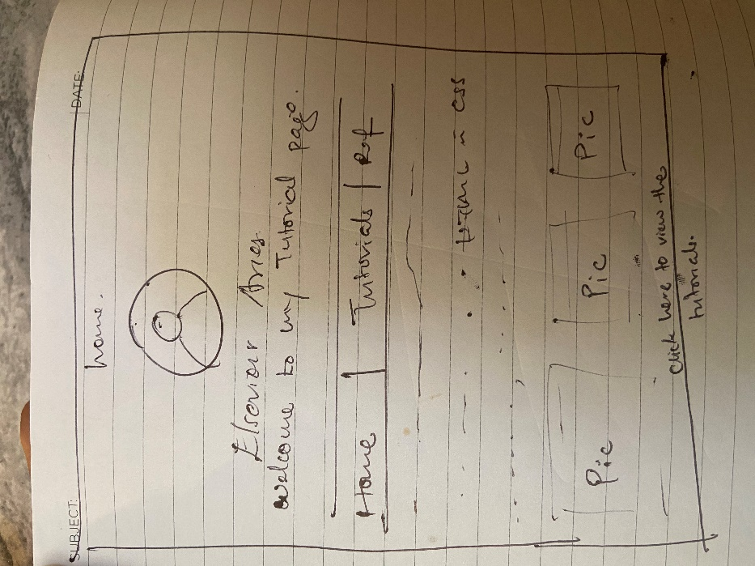

The basic elements of web developing can be challenging and confusing at times, especially when practice isn’t done often. There were many challenges and brainstorming moments throughout developing this website. One major frustration of coding in general could be the fact that punctuation and spelling matter massively. One big significant function of a web page could not be working properly or entirely due to having punctuation in the wrong places such as semi colons and colons.

The use of coding validators was significant to pinpointing errors that were in the code that may have not been picked up. Not all errors in code can be picked up by the text editor which mainly focuses on syntax errors. The validation of code allows the website being developed to be accessible by all clients on the net. W3C have set standards that developers are meant to follow, which eliminate basic errors that can cause problems when displaying the web page.

Below are screenshots that show my code on all 3 pages are validated and have passed the official HTML5 specification:

Below is a image that shows the stylesheet used for the website has passed the official CSS validation:

The code validators used for this website were [https://validator.w3.org/](https://validator.w3.org/#validate_by_uri+with_options) (for HTML) and <https://jigsaw.w3.org/css-validator/> (for CSS). Upon using the validators, there were several errors I had not picked up neither did Visual Basic, mainly closing tags for opened tags in the body, adding alternate text to images and icons used, correct format for spelling on the icons used (No spaces in the name od the icon) and further showing pieces of unnecessary code that the website could do without and still function effectively.

Throughout developing this website, it has been very essential to comment out code for the purpose of remembering what it does. Commenting out code helps a lot when it comes to cross referencing another chunk of code that may have similar functions. As well as it allows for better understanding of the code even from an outsider’s point of view or if it was a Collaboratory project.

In conclusion, the task at hand was a fairly challenging but straightforward at the same time that allowed me to use my own research and concepts taught in lectures as well. Incorporating material taught in lessons and using material provided from NILE, allowed a more learn-as-you-go experience which added to my knowledge on the topic. I would like to better my coding skills in CSS and play a lot more with the aesthetics of a website as well as its structure in HTML.